**Project Report Template**

1. **Introduction**
   1. Overview

A subscriber to a channel on the video- a list of its most-subscribed channels in April 2006. An early archive of the list dates to May 2006. Sharing you Tube is a user who has chosen to receive the channel’s content by clicking on that channel’s “subscribe” button, and each user’s subscription feed consists of videos published by channels to which the user is subscribed. The ability to subscribe to users was introduced in October 2005. YouTube began publishing

**Purpose:**

* The main purpose of YouTube is to provide a platform for users to watch, share, and create videos.
* YouTube as an information disseminating platform for students.

1. **Problem Definition & Design Thinking**
   1. Empathy Map

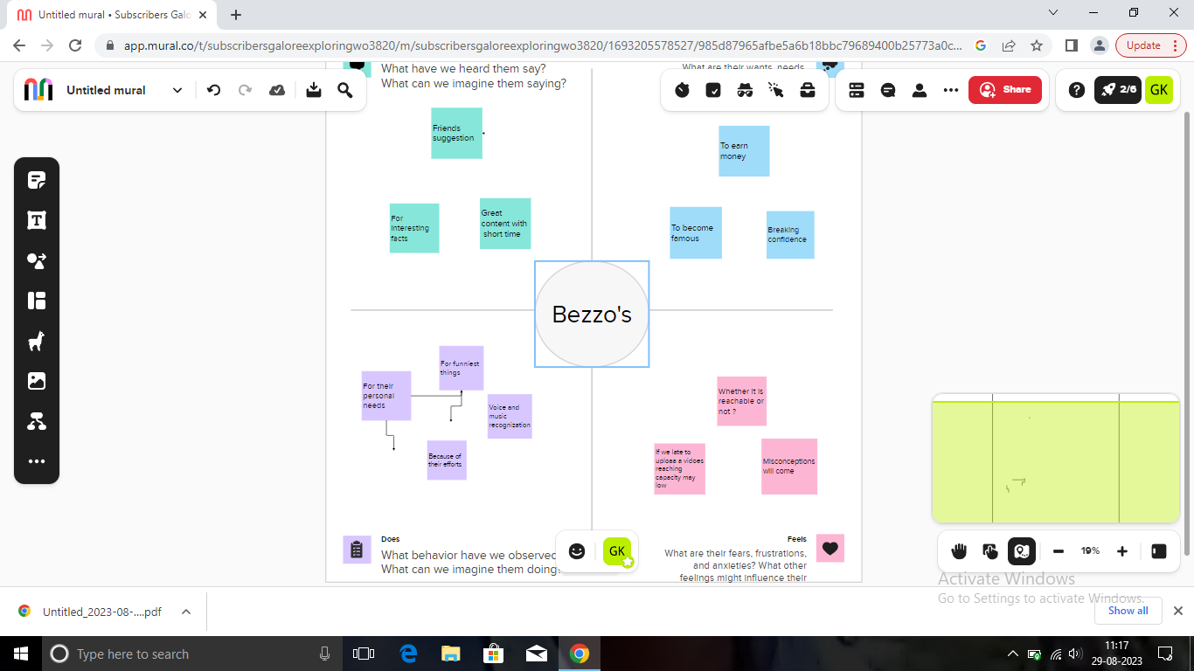

* 1. Ideation & Brainstorming Map

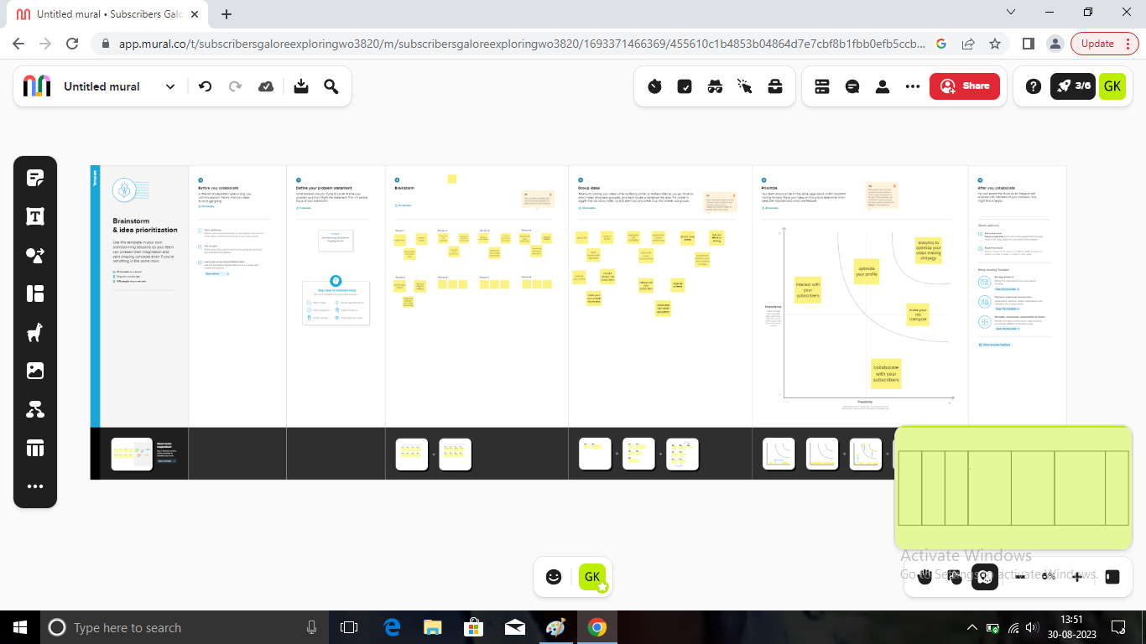

1. **Result**

Dashboard 1:

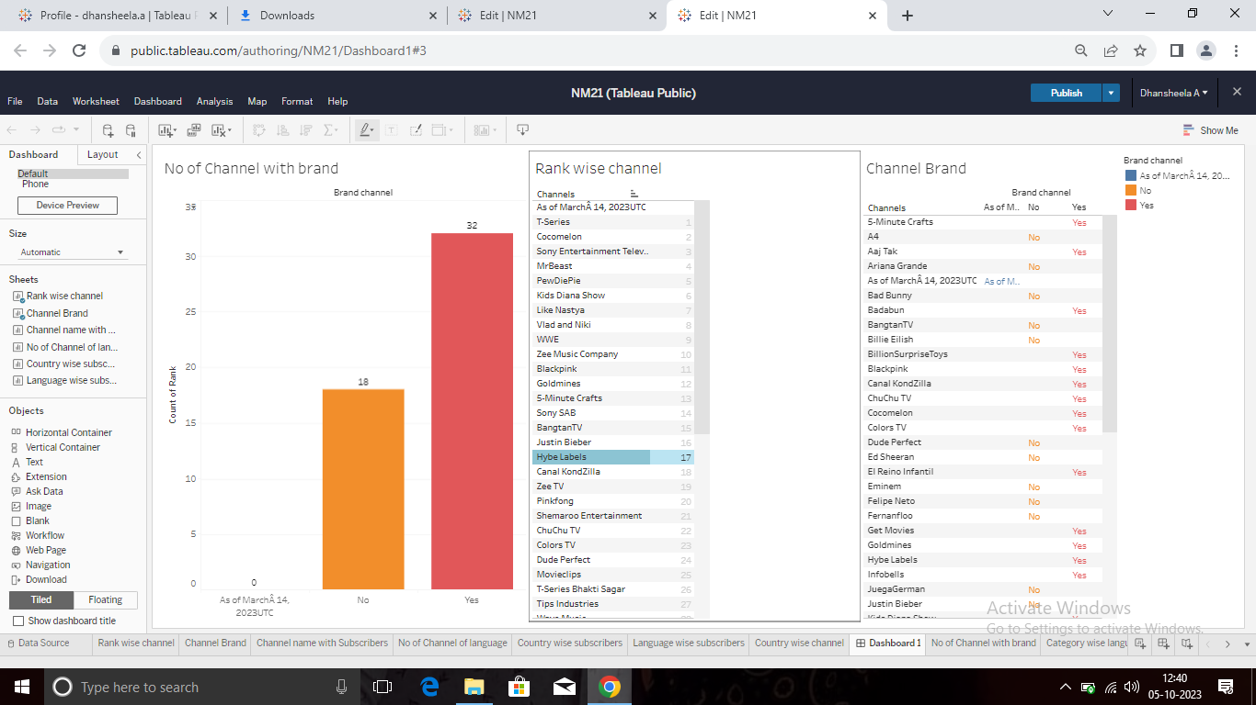

Dashboard 2:

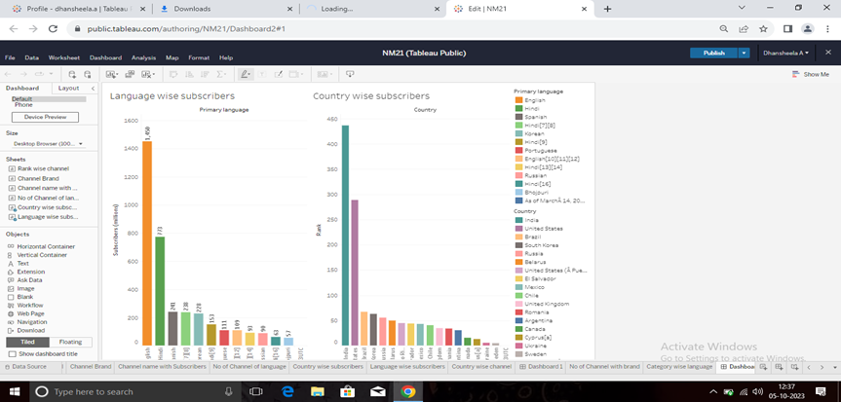

Dashboard 3:

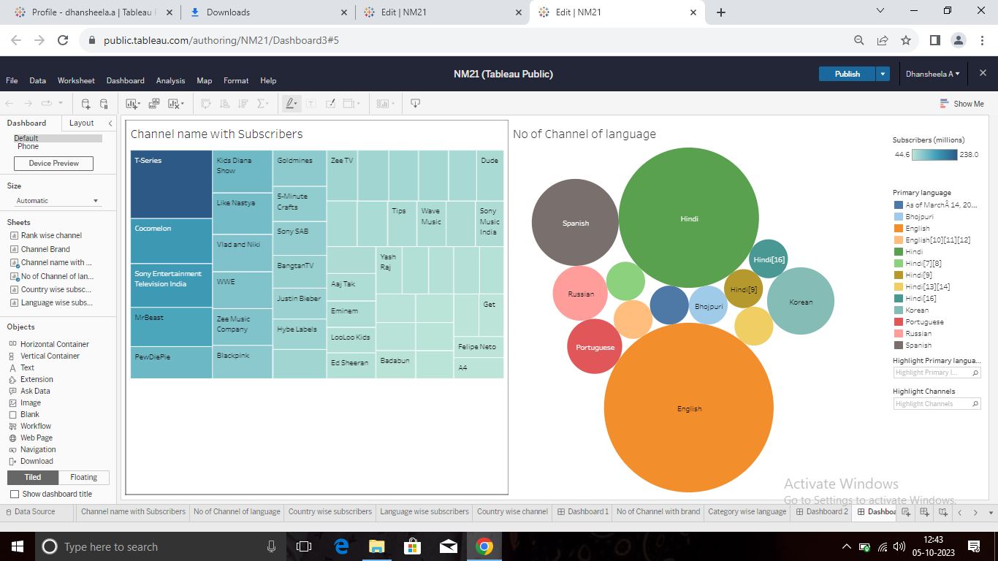Dashboard 4:

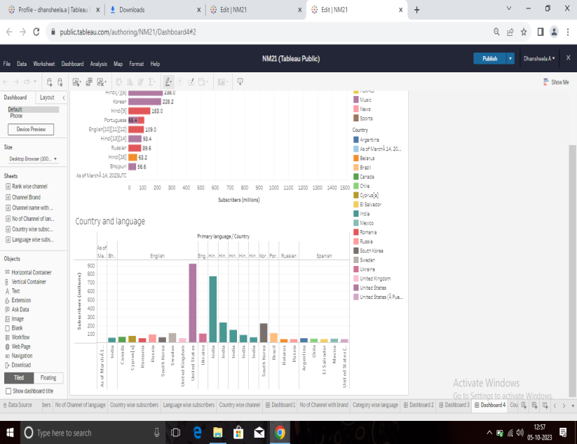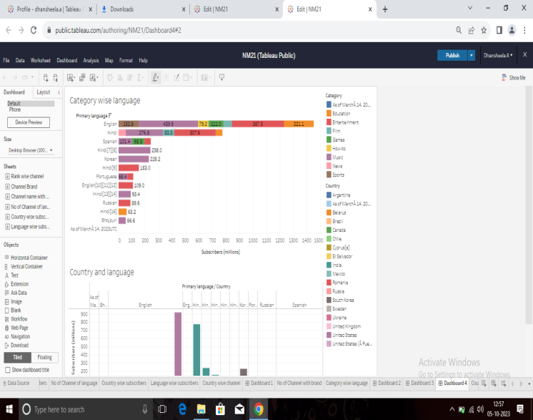

Story1:

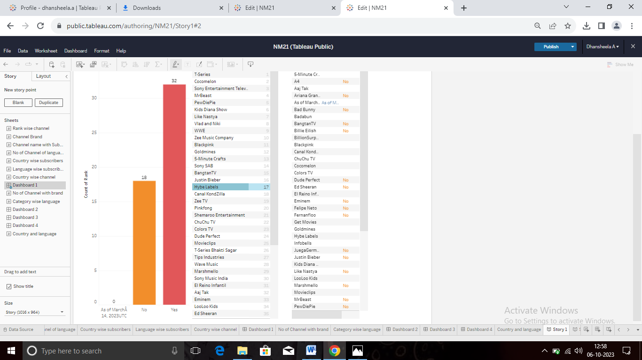

Story 2:

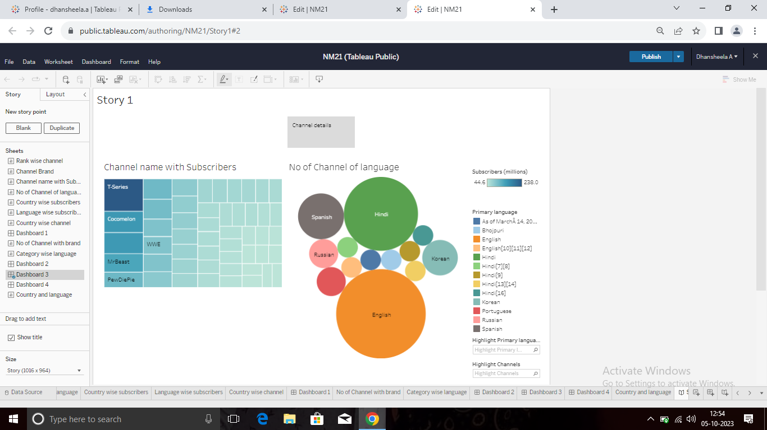

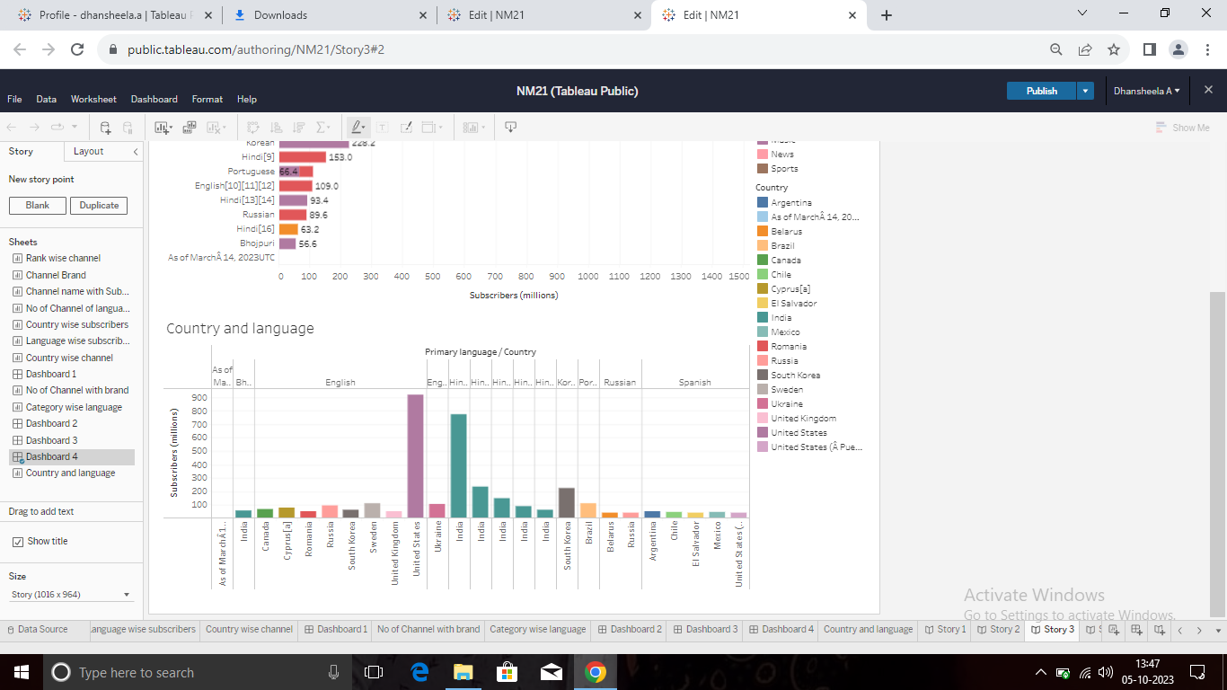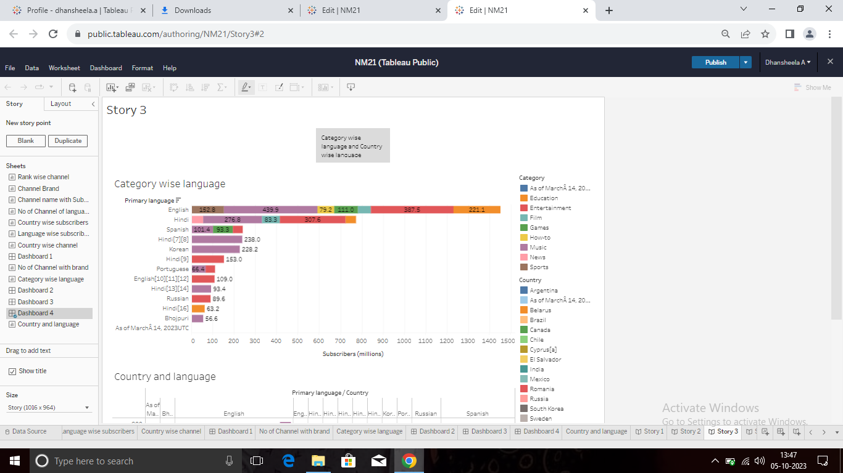Story 3:

Story 4:

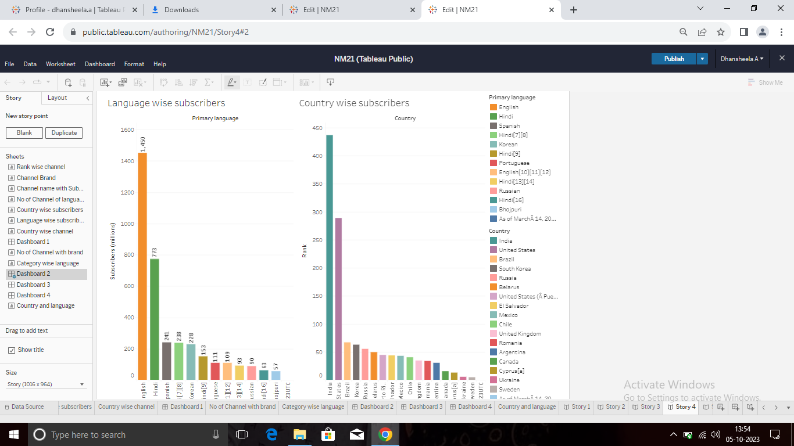

Story 5:

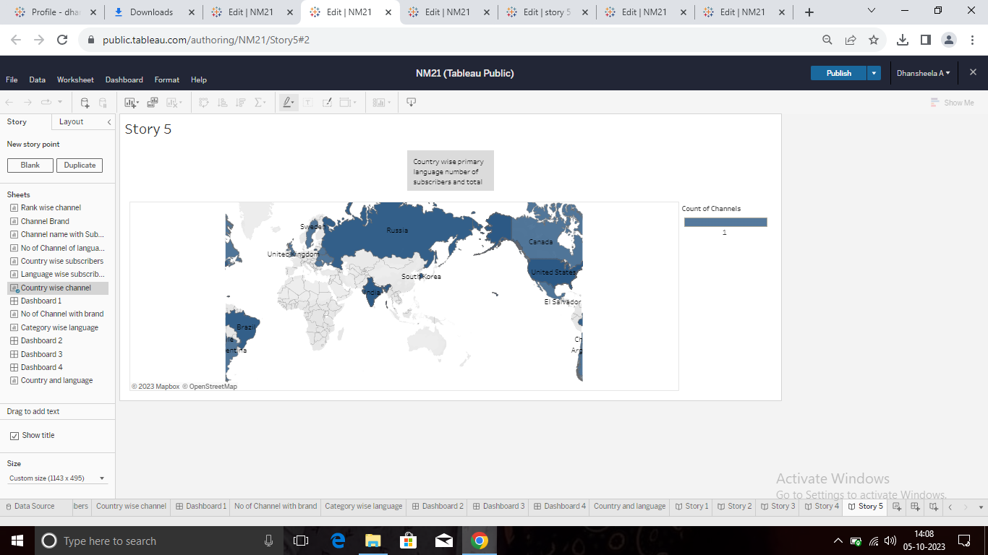

**4 ADVANTAGES & DISADVANTAGES**

|  |  |
| --- | --- |
| **Advantages** | **Disadvantages** |
| Easy Earning is at the very top of the list of YouTube benefits for Vloggers. | Despite the disclaimer of the company, users are still free to upload the videos at free wall. |
| For Brand Promotion | Sometimes the content is misleading. |
| It’s the perfect place to learn and gain experience. | Any advertisement can be uploaded in the middle of a video without any permission this can hamper a creators videos and also effect the subscribers. |
| YouTube monetization can make the channel another source of subscribers | Everything is public your account can be disabled without any reason. |
| Can connect more subscribers | People can affect others in a negative way through videos |

**5 APPLICATIONS**

* Build a deeper connection with your viewers by sharing content you can’t publish on YouTube.
* Social interactions are generated for each minute of video uploaded by the top 1,000 channels.
* The Combination of visuals and audio-along with YouTube content culture of simple, digestible meaning.

**6 CONCLUSION**

There are many positive aspects to keep in mind about YouTube in comparison to the negatives. By analysing the positives and negatives of YouTube, it is possible to get an idea of the number of users who receive the information and what percentage of them are misleading. The whole thing is based on people’s interests, which is the reason You Tube exists, and so do YouTube channels.

**7 FUTURE SCOPE**

In the YouTube career, individuals generally, work for themselves and don’t need to join a specific organization or company to get employed. Subscribers play a pivotal role in a YouTubers career as more subscribers come with more views on content, followed by more money-making.